**Week 12 First Attempt at a Literature Search**

**Topic:** The Impact of ChatGPT on User Search Habits and Internet Search Engines.

After reading Newing, H. (2010). Conducting Research in Conservation: Social Science Methods and Practice. United Kingdom: Taylor & Francis, I use its strategies to do a search on Google, Google Scholar and the University of the Arts London's online library. In addition, in order to diversify the search results, I also searched the answers on the Chinese search engine Baidu. Since my topic is related to ChatGPT, I will also type the question into ChatGPT and see what answer it gives me. Here is my search process.

1. **Google/Baidu**

I used the keywords "ChatGPT", "search habits", "search engine", "artificial intelligence", and "user behaviour" to search on google and Baidu. However, these words have too many search results, and they are not highly relevant to my topic. I try to use the Boolean operator "AND" to combine them. (Google do not need "AND", just put words together)

In addition, we know that the emergence of Internet search engines has greatly influenced libraries and paper encyclopedias. This has a similar history to ChatGPT affecting search engines, so I also use "search engines AND libraries" as a keyword reference. 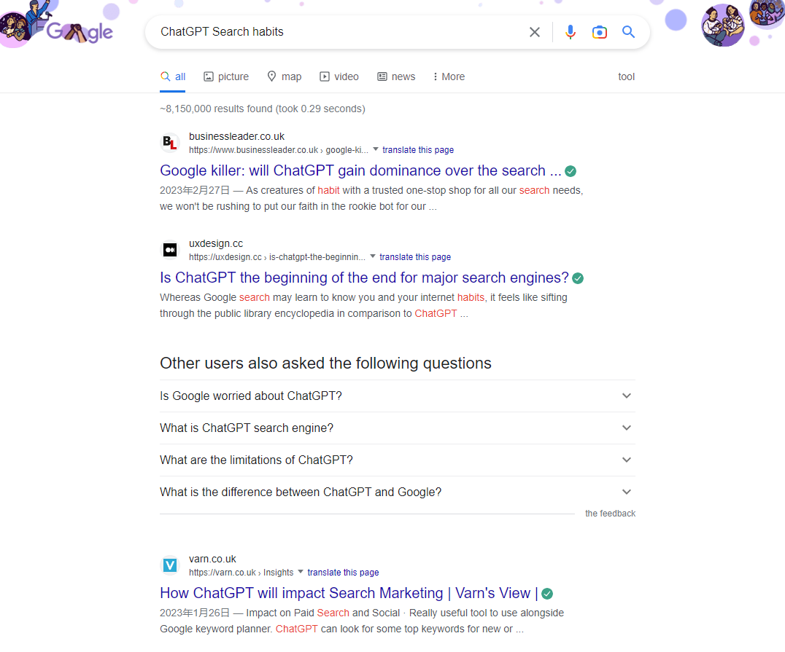

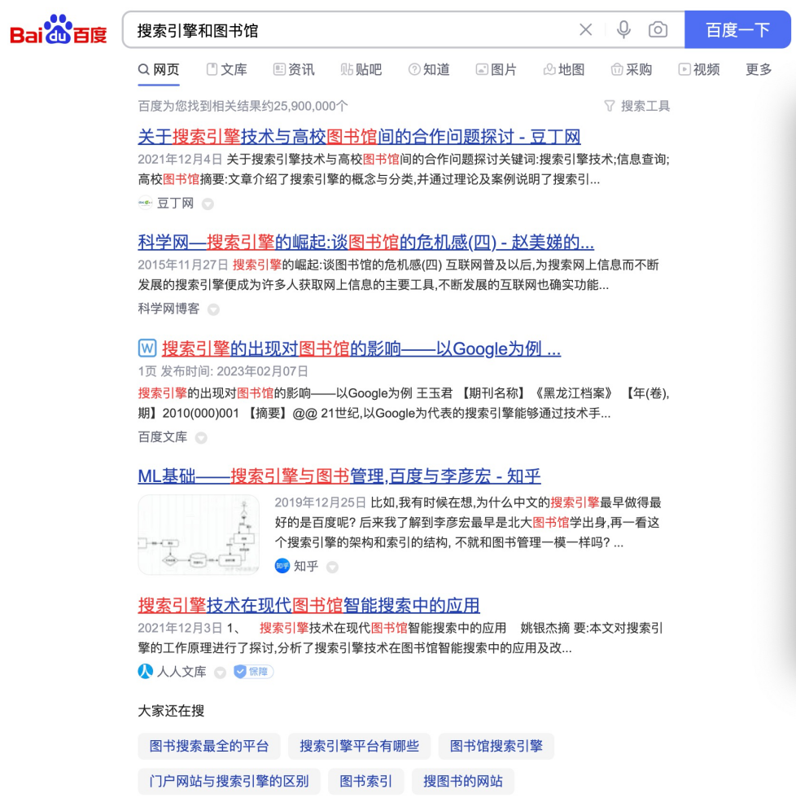

Among them, the Search results of "ChatGPT AND Search habits" AND "ChatGPT and search engines" are very similar, and I also found a lot of materials related to my research. The search results for "ChatGPT AND Future", however, are not good. The number of results is very high across different engines, but there are not many references. I think "Future" is too broad a term. In addition, The results of "Artificial intelligence AND User behaviour" are not very relevant to my research, but I have learned some examples of the effects of artificial intelligence in many other fields on user behaviour. The "Search engines AND libraries" is very helpful, and one of the articles discusses the cooperation between search engines and libraries.

1. **Google scholar**

Because ChatGPT launched in 2023, I changed my search scope to 2023, which helped me filter out a lot of useless articles. An article in Google Academics caught my eye, Chatting about ChatGPT: how may AI and GPT impact academia and libraries? The article stresses that ChatGPT's power will boost academia and libraries, but the key is how to use the technology in a responsible and ethical way.

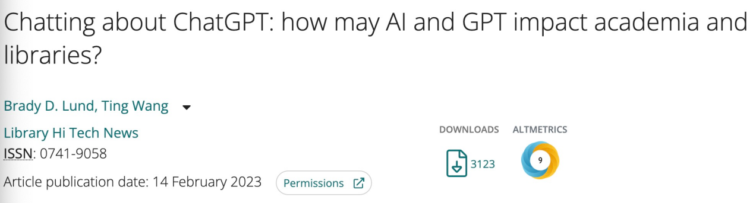

1. **UAL library**

I did a library search using the above keywords with very few results and searched for ChatGPT without anything. So I used the succinct words "artificial intelligence" and "search engine." AI: the tumultuous history of the search for an artificial intelligence/Daniel Crevier. Let me know some history of artificial intelligence, which laid the foundation for research. 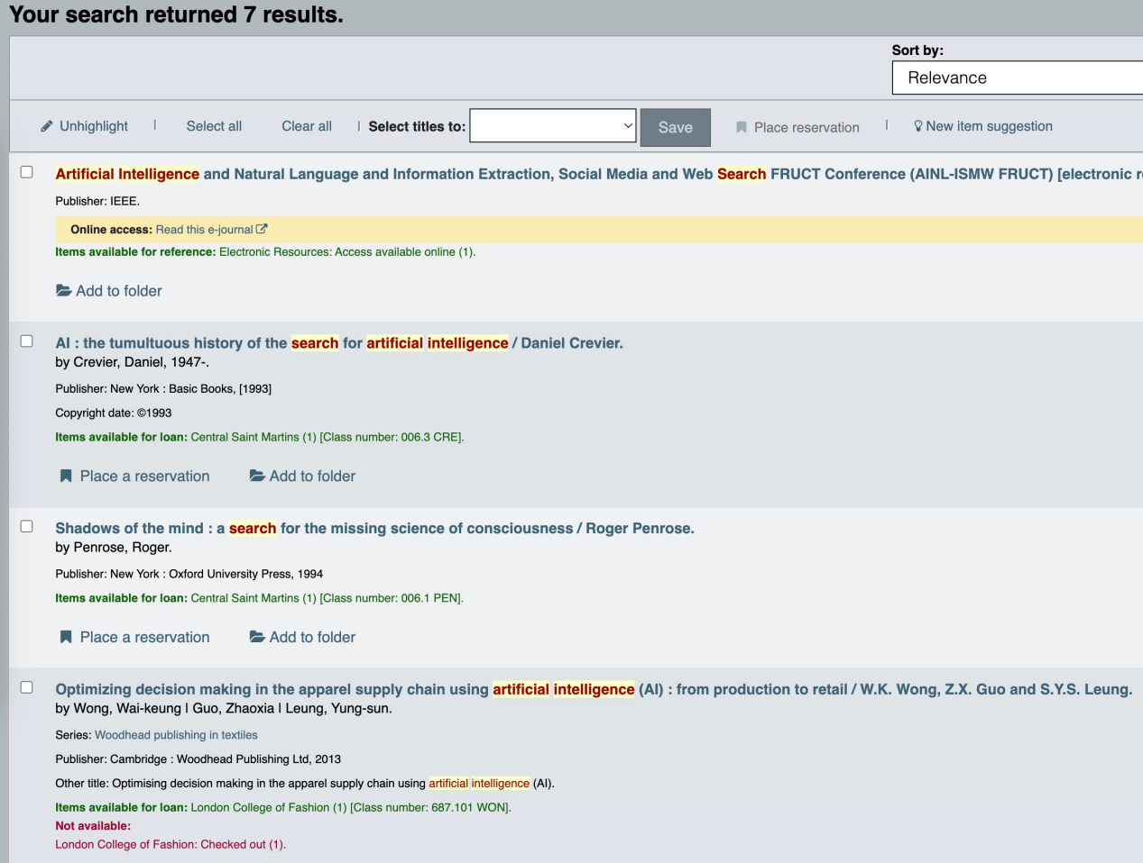

1. **Keyword summary**

|  |  |  |
| --- | --- | --- |
| Keywords | Suitable engine | Advantages and disadvantages |
| ChatGPT/search habits/search engines | Not good | Too much results |
| ChatGPT impact | Google scholar | Strong correlation |
| Artificial intelligence | UAL library | Used to expand search results |
| ChatGPT AND Search engine/habit | Google/Baidu | Strong correlation, but similar results |
| Artificial intelligence AND User behavior | Not good | not very relevant |
| Search engines AND libraries | Google/Baidu | Similar history |
| ChatGPT AND future | Not good | "Future" is too broad |

1. **ChatGPT**

Here are two questions I chose to ask ChatGPT.

